姓名 | 岳天奇
教育与工作经历 | 2013~2017，大连理工大学，机械设计制造及自动化，工学学士  2017~2019，哈尔滨工业大学，机械电子工程，工学硕士  2019~2024，University of Bristol，工程数学，哲学博士  2024~2025，University of Bristol，博士后研究助理  2025~今，南方科技大学自动化与智能制造学院，副教授
电子邮箱 | yuetq@sustech.edu.cn
个人照片 | 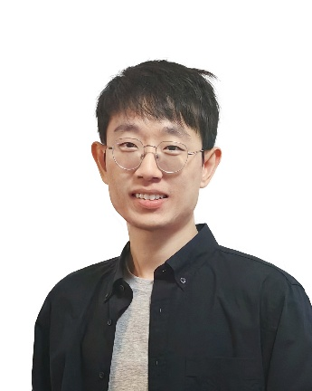
研究领域 | I am interested in the following research areas:  - Design and application of bioinspired suction mechanisms in robotics: particularly how physical intelligence can be embedded in soft robots to integrate adhesion, perception, decision-making, and actuation through suction flow. This includes the development of highly adaptive robotic suction grippers and wall-climbing robots that achieve superior load-to-energy efficiency.  - Biomimetic humanoid robotic systems: focusing on the design of highly flexible bioinspired joints, as well as the integration and control of human-like muscle groups to achieve more natural and efficient movement.  - Soft robotics: including soft grippers, actuators, variable stiffness devices, and the broader concept of embodied physical intelligence in soft robotic systems.  - Other research directions in robotics: such as system design, fabrication, integration, sensing, and control, where I am always open to exploring new ideas and technologies.
自我介绍 | Hi, I'm an Associate Professor at the School of System Design and Intelligent Manufacturing (自动化与智能制造学院), Southern University of Science and Technology (SUSTech, 南方科技大学), and the Principal Investigator of the Bioinspired Intelligent Robotic Design Lab (BIRD Lab, 仿生智能机器人设计实验室).  Our philosophy at BIRD Lab is to draw inspiration from nature - not just by mimicking biological forms, but by capturing their essence and embedding that intelligence into the core of robotic systems. Our goal is to create robots that can interact with humans smoothly, safely, and naturally.  We're always excited to welcome motivated and creative students to join us in an open and flexible way. We're also very open to industry collaborations - let's explore what we can build together!
论文发表情况 | Selected Publications:  *: corresponding author; #: representative publication  1#. Yue, T., Lu, C., Tang, K., Qi, Q., Lu, Z., Lee, L. Y., Bloomfield-Gadêlha, H., & Rossiter, J.* (2025). Embodying soft robots with octopus-inspired hierarchical suction intelligence. Science Robotics (Cover illustration, introduced in Newton magazine), 10(102), eadr4264. DOI: https://doi.org/10.1126/scirobotics.adr4264  2#. Yue, T., Bloomfield-Gadêlha, H., & Rossiter, J.* (2024). Snail-inspired water-enhanced soft sliding suction for climbing robots. Nature Communications (Highlighted, pressed by BBC), 15(1), 4038. DOI: https://doi.org/10.1038/s41467-024-48293-2  3#. Yue, T., Si, W., Keller, A., Yang, C., Bloomfield-Gadêlha, H., & Rossiter, J.* (2024). Bioinspired multiscale adaptive suction on complex dry surfaces enhanced by regulated water secretion. Proceedings of the National Academy of Sciences (selected in “This week in PNAS”, interviewed by Associated Press), 121(16), e2314359121. DOI: https://doi.org/10.1073/pnas.2314359121  4. Yue, T.*, Bloomfield-Gadêlha, H., & Rossiter, J. M. (2023). Shape-Conformable Suction Cups with Controllable Adaptive Suction on Complex Surfaces. IEEE Robotics and Automation Letters, 8(11), 7735-7742.  5. Yue, T.*, Si, W., Partridge, A. J., Yang, C., Conn, A. T., Bloomfield-Gadêlha, H., & Rossiter, J. M. (2022). A Contact-triggered Adaptive Soft Suction Cup. IEEE Robotics and Automation Letters (with ICRA 2022 oral presentation), 7(2), 3600 - 3607.
*填写完成后删除括号内原文和示例图片

